Documentation

Note: I am using full HD mode

Assets I used:

tower-defense-kit by kenney <https://kenney.nl/assets/tower-defense-kit>

Texture:

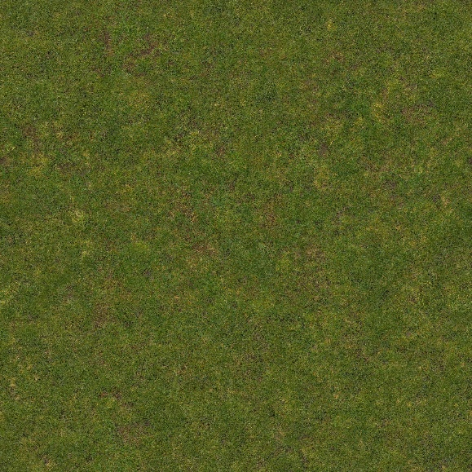

Figure 1: Poliigon.[US]. *Poliigon_GrassPatchyGround_4585_BaseColor.* (Poliigon, 2025)

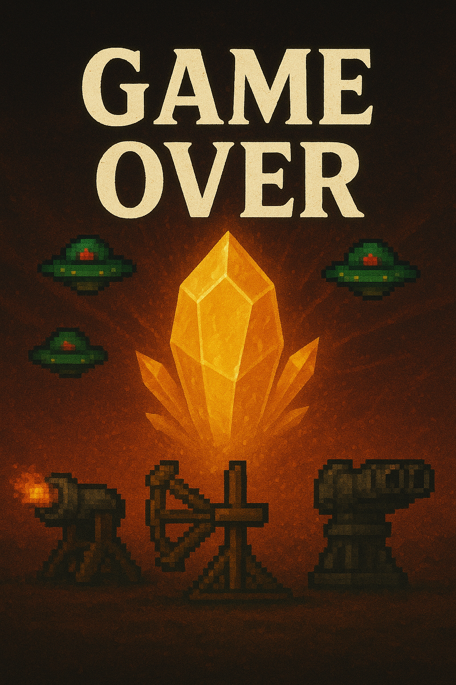

Figure 2: ChatGPT. [SA]. *Game Over background image*. (ChatGPT, 2025)

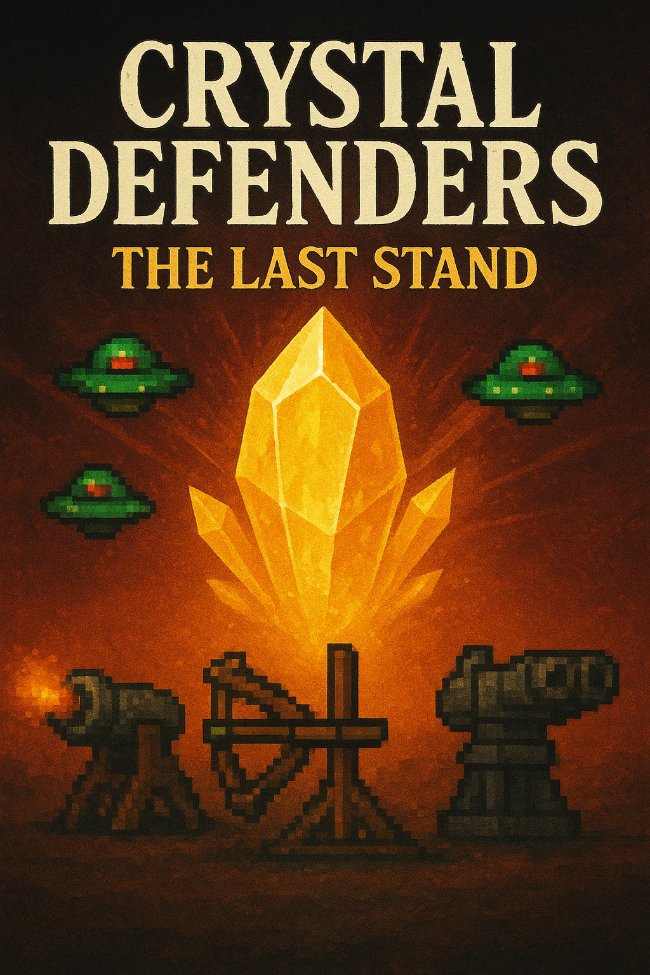

Figure 3: ChatGPT. [SA]. *Main menu background image*. (ChatGPT, 2025)

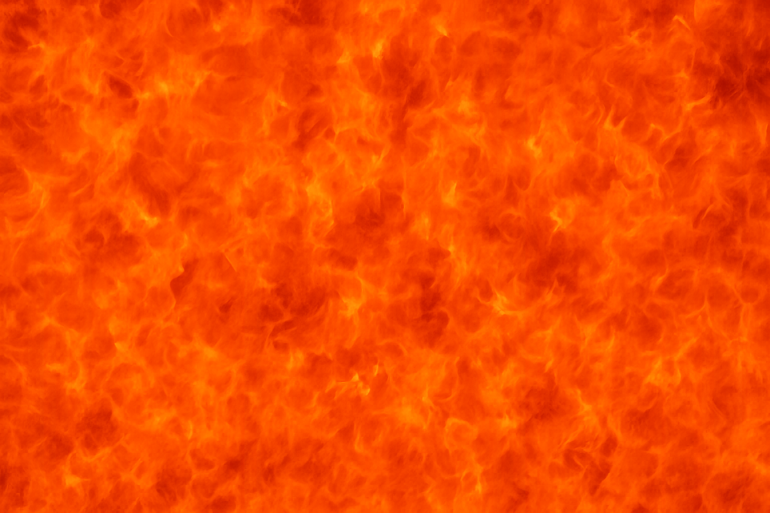

Figure 4: ChatGPT. [SA]. *Fire flat texture*. (ChatGPT, 2025)

# References

ChatGPT, 2025. *Fire flat texture.* [Online]   
Available at: https://chatgpt.com/  
[Accessed 15 October 2025].

ChatGPT, 2025. *Game Over background image.* [Online]   
Available at: https://chatgpt.com  
[Accessed 15 October 2025].

ChatGPT, 2025. *Main menu background image.* [Online]   
Available at: https://chatgpt.com/  
[Accessed 15 October 2025].

Poliigon, 2025. *Flat Grass Texture-Poliigon.* [Online]   
Available at: https://www.poliigon.com/texture/flat-grass-texture/4585  
[Accessed 08 September 2025].

List of Figures:

Figure 1: Poliigon.[US]. *Poliigon_GrassPatchyGround_4585_BaseColor.*

Figure 2: ChatGPT. [SA]. *Game Over background image*.

Figure 3: ChatGPT. [SA]. *Main menu background image*.

Figure 4: ChatGPT. [SA]. *Fire flat texture*.